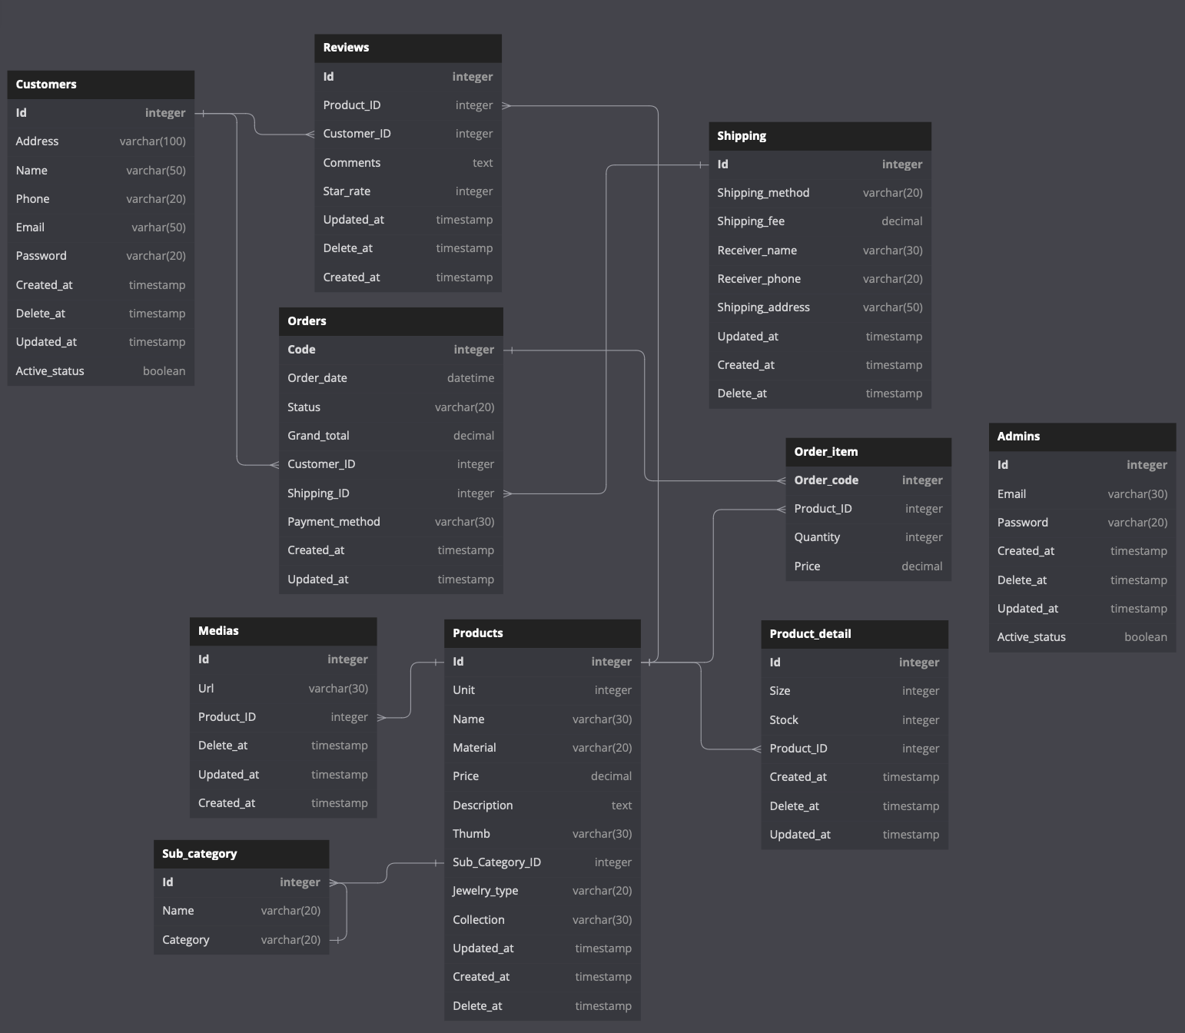

Figure 1: AGURI's DB Diagram

Table Customers {

Id integer [primary key]

Address varchar(100)

Name varchar(50)

Phone varchar(20)

Email varhar(50)

Password varchar(20)

Created_at timestamp

Delete_at timestamp

Updated_at timestamp

Active_status boolean

}

Table Orders {

Code integer [primary key]

Order_date datetime

Status varchar(20)

Grand_total decimal

Customer_ID integer

Shipping_ID integer

Payment_method varchar(30)

Created_at timestamp

Updated_at timestamp

}

Table Shipping {

Id integer [primary key]

Shipping_method varchar(20)

Shipping_fee decimal

Receiver_name varchar(30)

Receiver_phone varchar(20)

Shipping_address varchar(50)

Updated_at timestamp

Created_at timestamp

Delete_at timestamp

}

Table Reviews {

Id integer [primary key]

Product_ID integer

Customer_ID integer

Comments text

Star_rate integer

Updated_at timestamp

Delete_at timestamp

Created_at timestamp

}

Table Medias {

Id integer [primary key]

Url varchar(30)

Product_ID integer

Delete_at timestamp

Updated_at timestamp

Created_at timestamp

}

Table Products {

Id integer [primary key]

Unit integer

Name varchar(30)

Material varchar(20)

Price decimal

Description text

Thumb varchar(30)

Sub_Category_ID integer

Jewelry_type varchar(20)

Collection varchar(30)

Updated_at timestamp

Created_at timestamp

Delete_at timestamp

}

Table Product_detail{

Id integer [primary key]

Size integer

Stock integer

Product_ID integer

Created_at timestamp

Delete_at timestamp

Updated_at timestamp

}

Table Order_item{

Order_code integer [primary key]

Product_ID integer

Quantity integer

Price decimal

}

Table Sub_category{

Id integer [primary key]

Name varchar(20)

Category varchar(20)

}

Table Admins{

Id integer [primary key]

Email varchar(30)

Password varchar(20)

Created_at timestamp

Delete_at timestamp

Updated_at timestamp

Active_status boolean

}

Ref: Customers.Id < Orders.Customer_ID

Ref: Customers.Id < Reviews.Customer_ID

Ref: Shipping.Id < Orders.Shipping_ID

Ref: Products.Id < Reviews.Product_ID

Ref: Products.Id < Order_item.Product_ID

Ref: Order_item.Order_code > Orders.Code

Ref: Products.Id < Medias.Product_ID

Ref: Products.Sub_Category_ID < Sub_category.Id

Ref: Sub_category.Id > Sub_category.Category

Ref: Product_detail.Product_ID > Products.Id